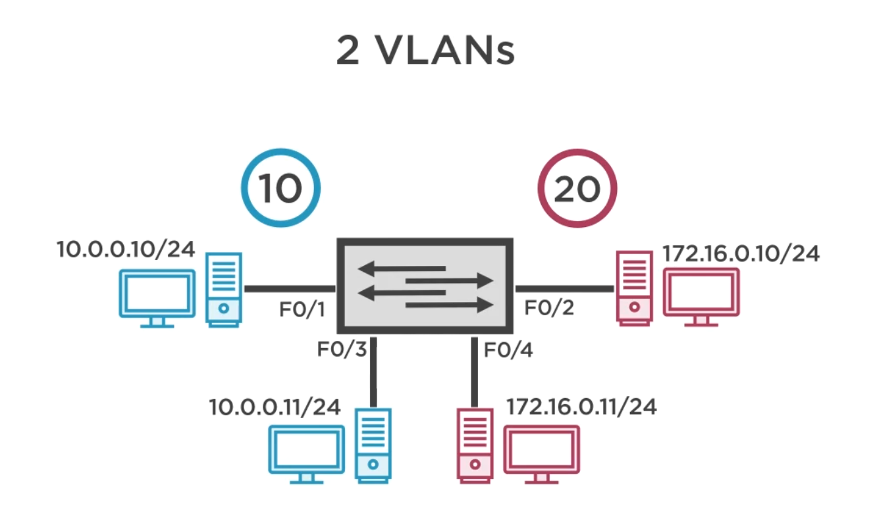

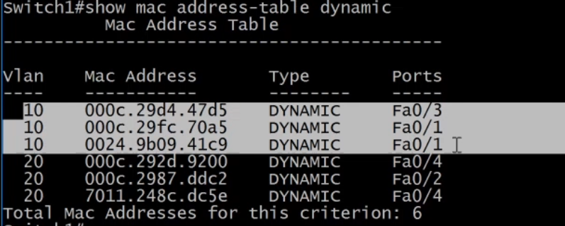

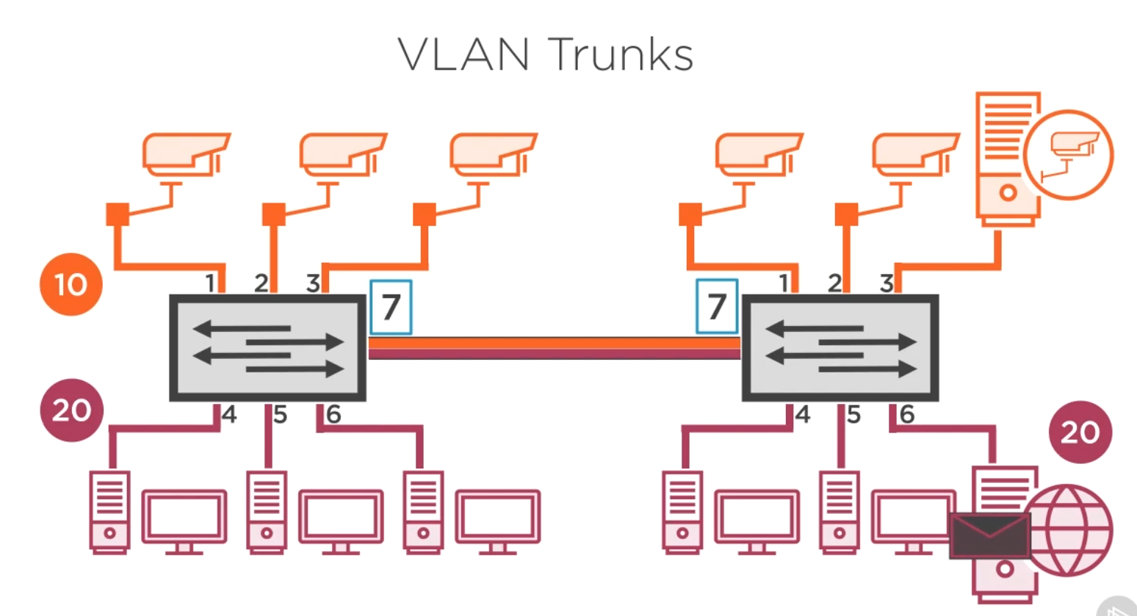

7 is a trunk port (tagged frame) allow vlan10 and vlan20 to reach its source & destination within its vlan not mixed.

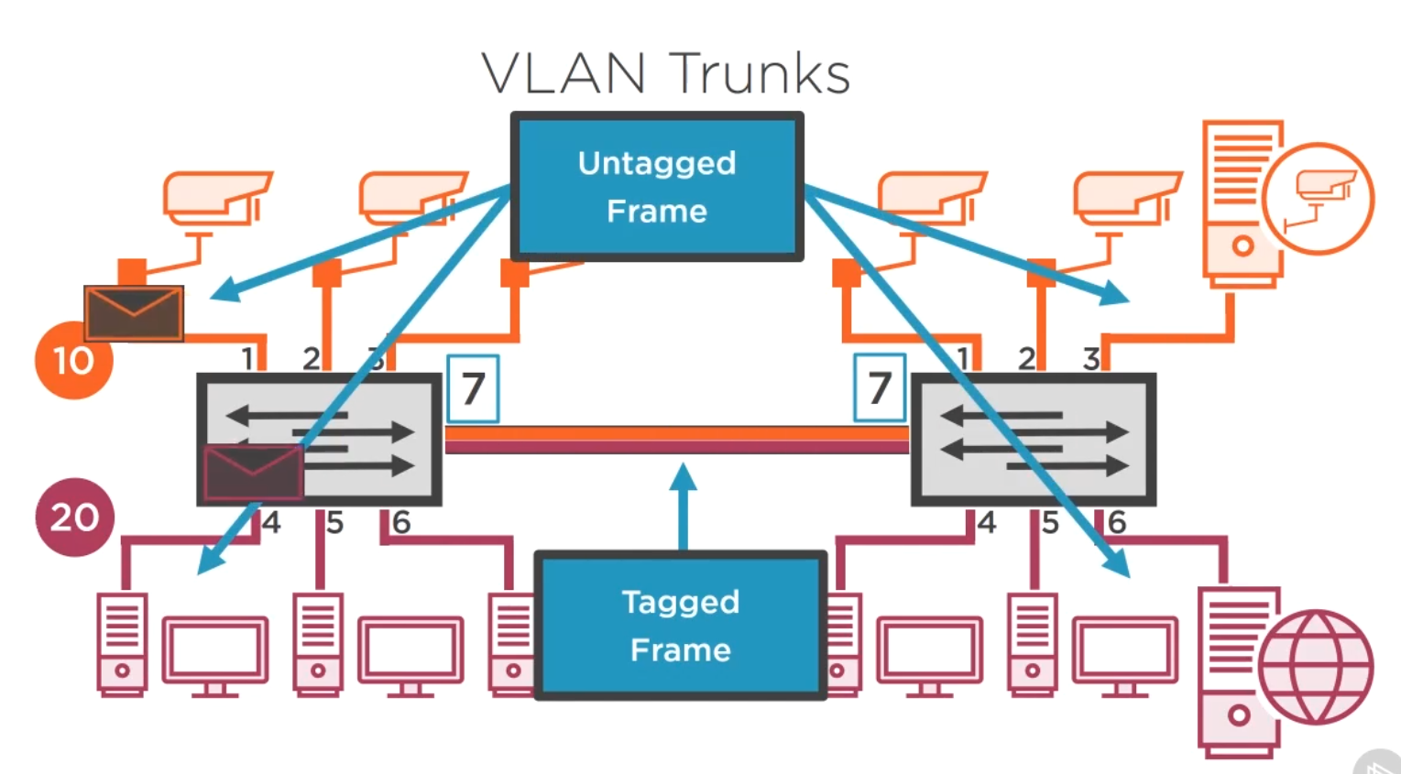

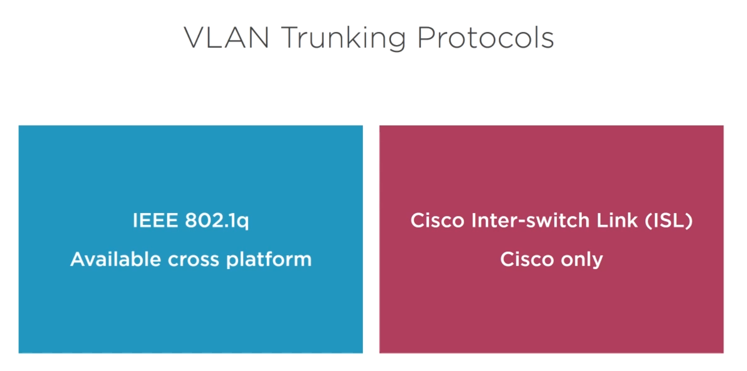

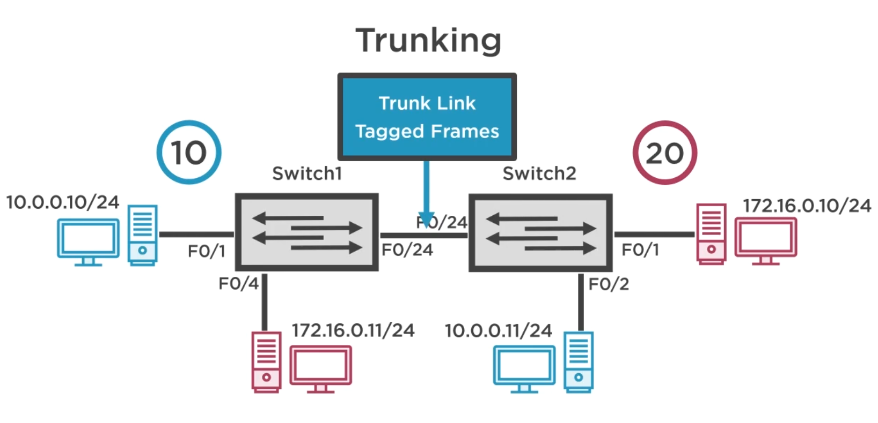

Vlan10 and vlan20 are using access port.

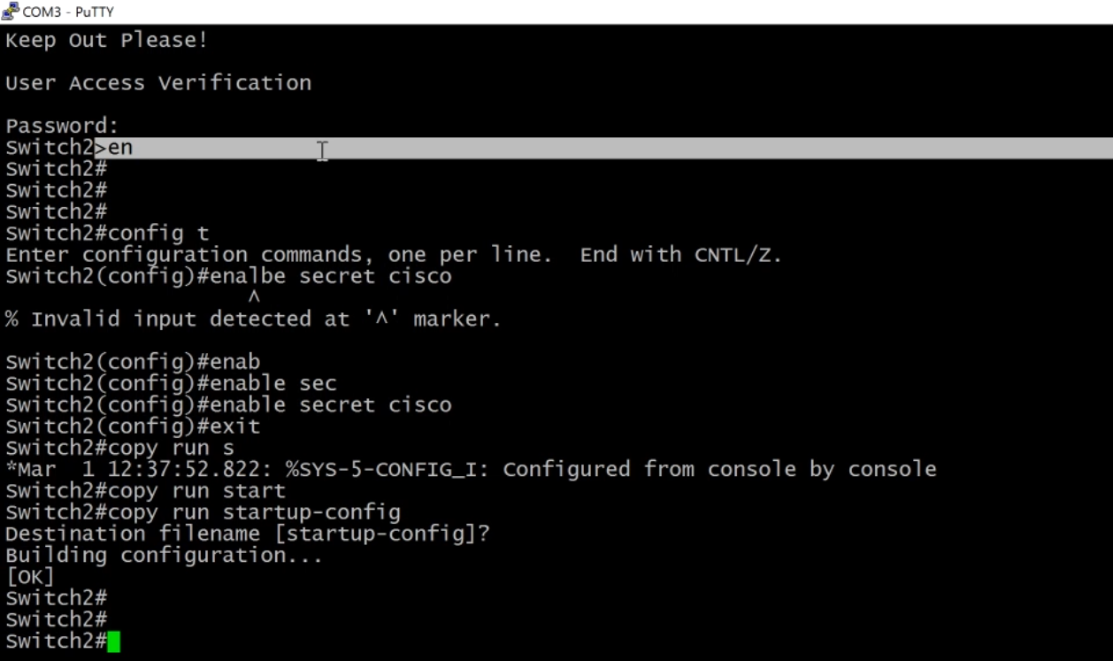

Setup authentication.

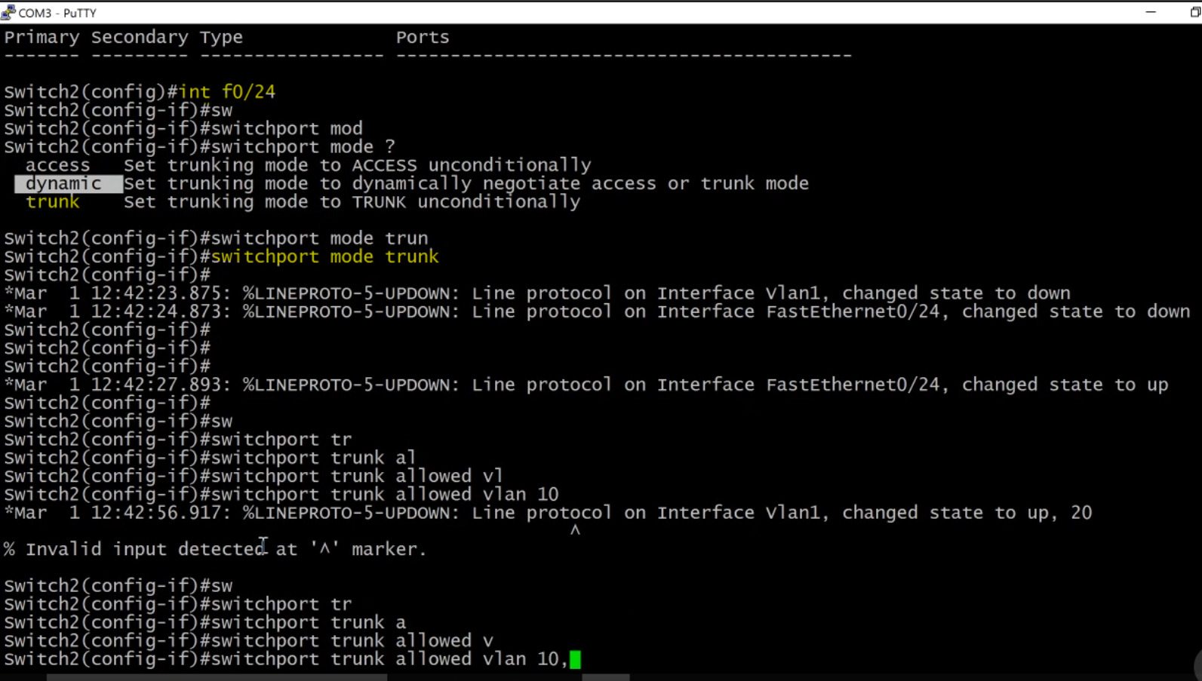



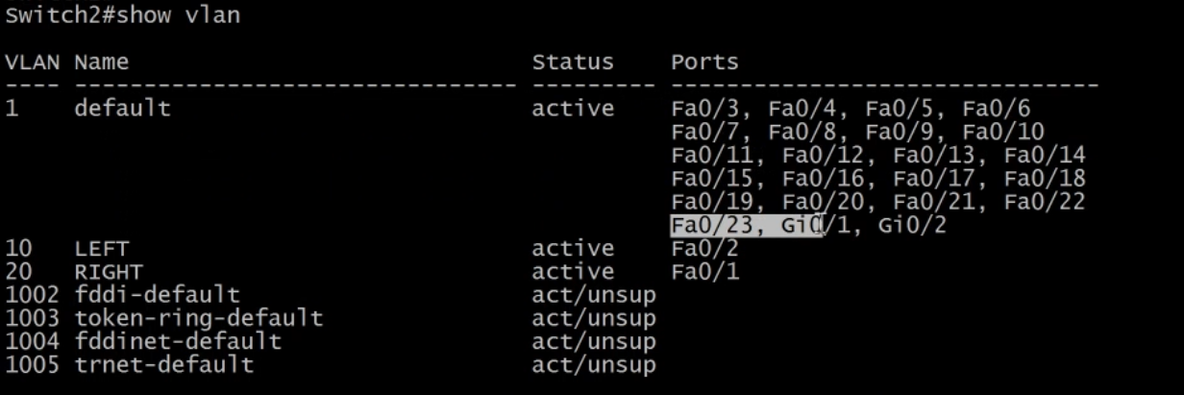

Now f024 is not list, because it’s a trunk port

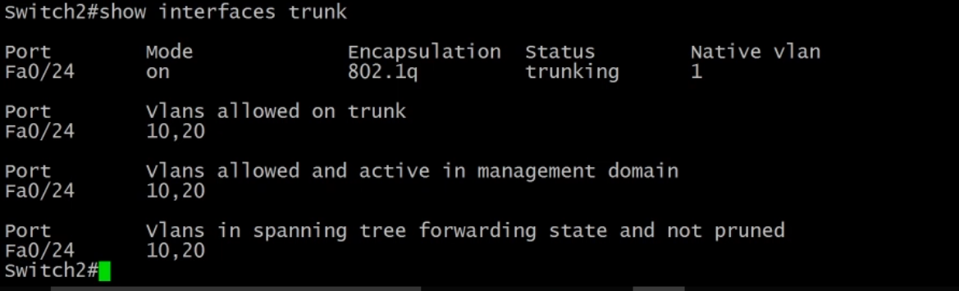

Native (vlan1) is allow you to send traffic across the link without tag (security concern)

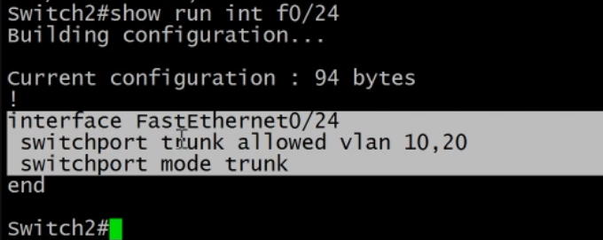

Copy these table value

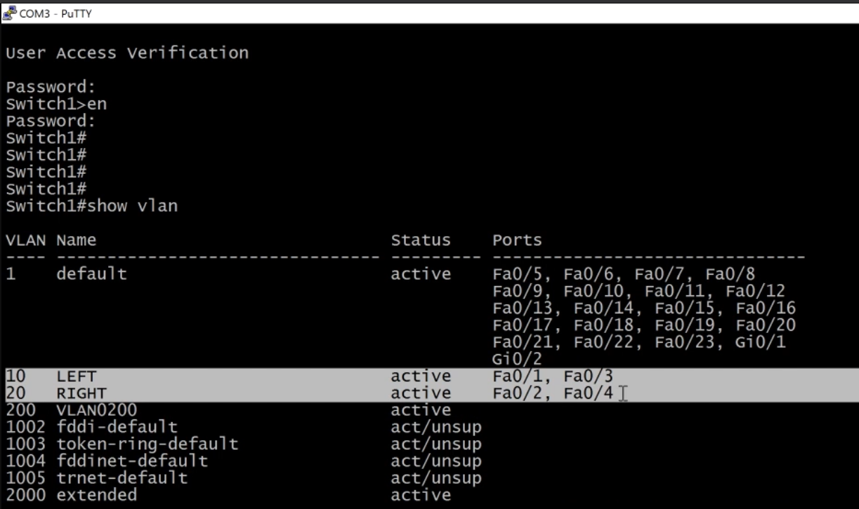

Switch cable to switch to switch1

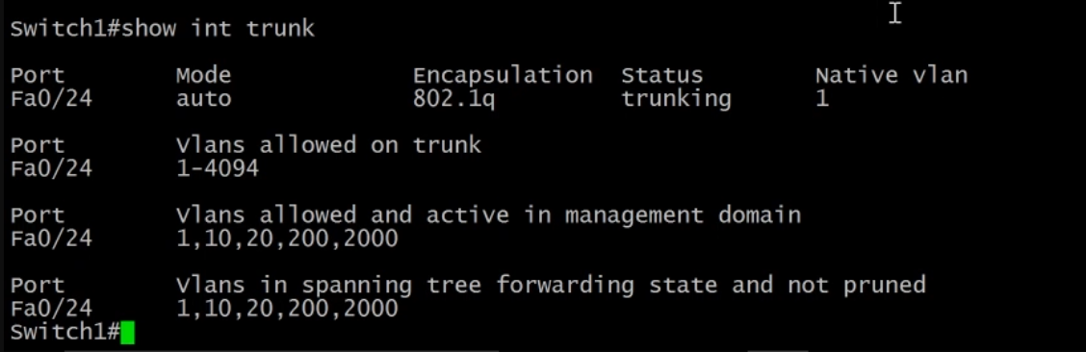

Auto configured on switch1, because using dynamic trunk method (make sure switch1 is plug into switch2), this pic also shown vlan 200 and 2000, but after you configured trunk it will disappear. See below.

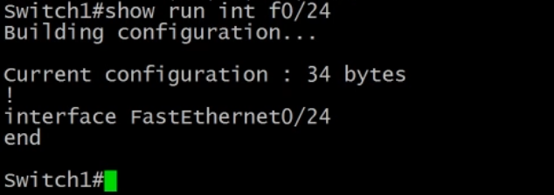

However configuration file is blank, danger!

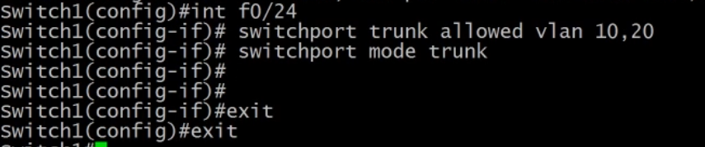

Configure trunk port (24), simple paste the previous copied command from switch1

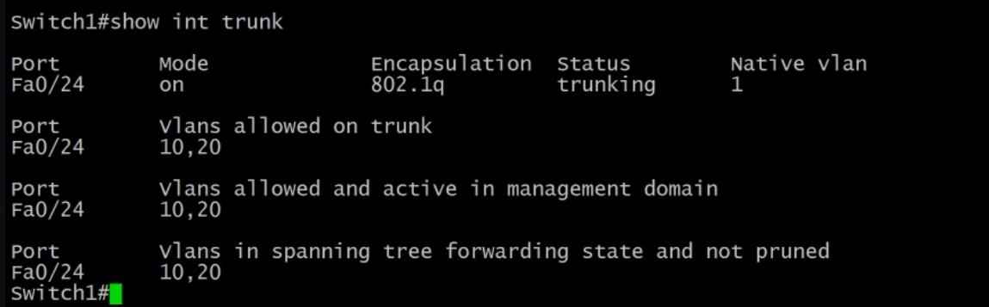

See here: cleaner, no more vlan200 or vlan2000

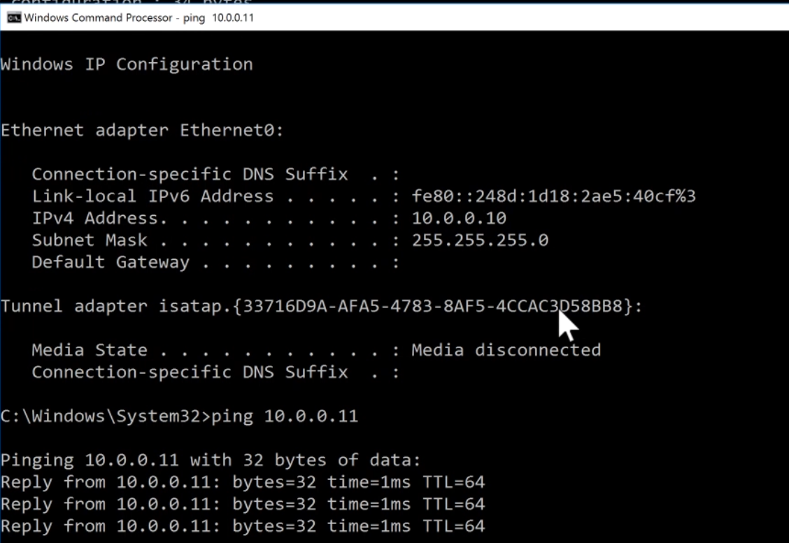

Test

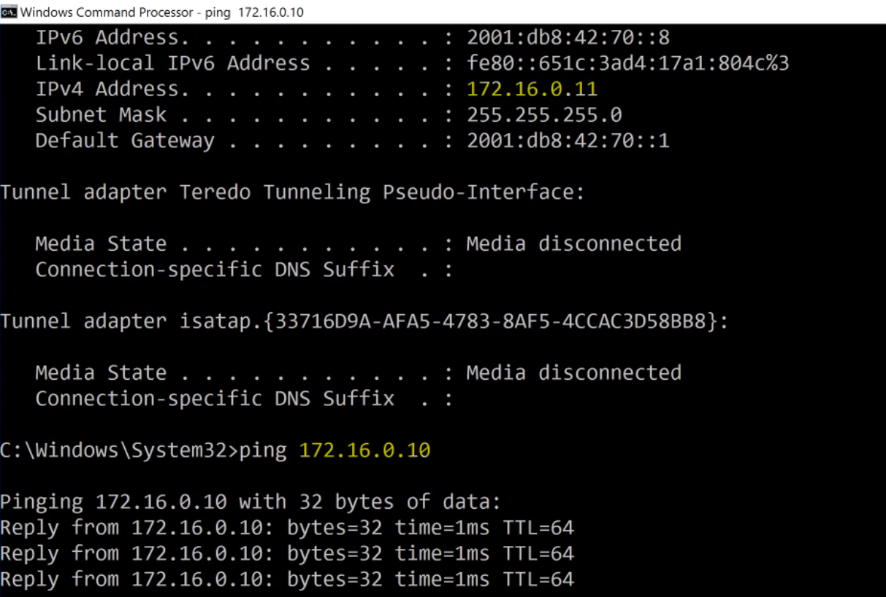

Nothing to do with gateway.

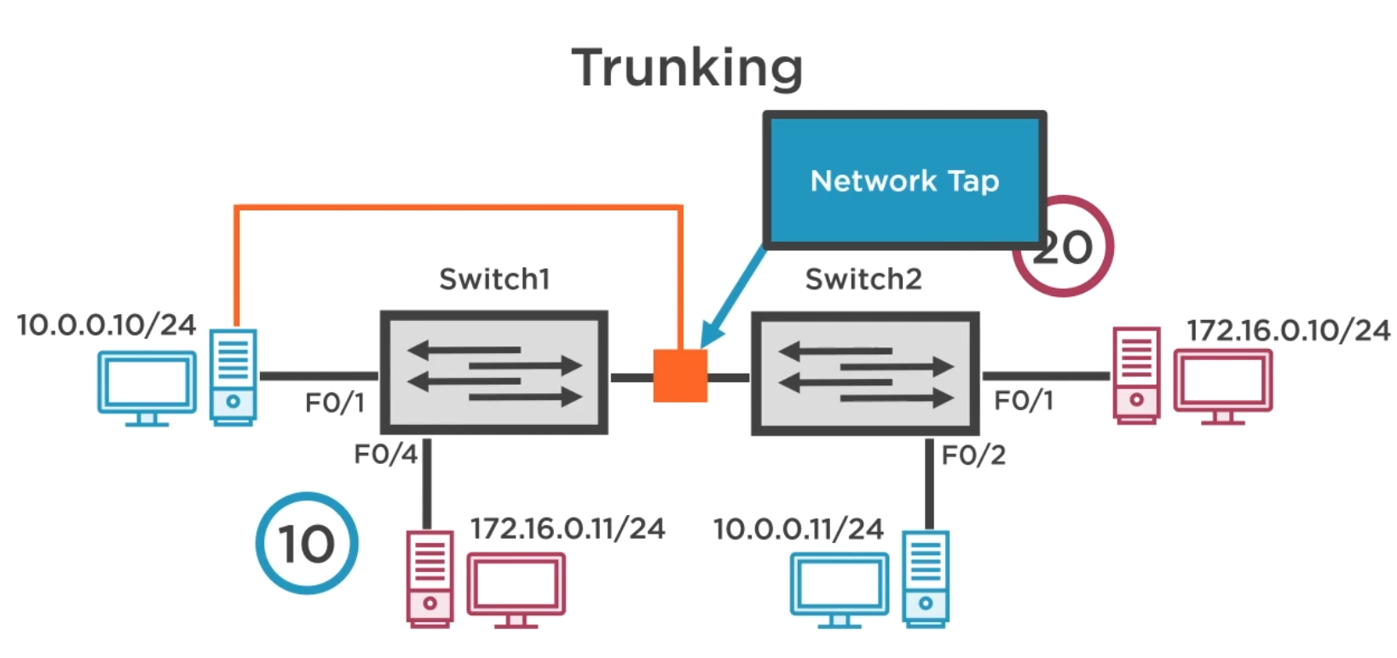

Capture tag frame, using network tap device (physical), plugged between 2 switches.

Other port on the network tap then run it back to windows work station to look at it.

Problem, windows tcp thingy strip of the frame tag, to resolve this use a linux workstation instead.

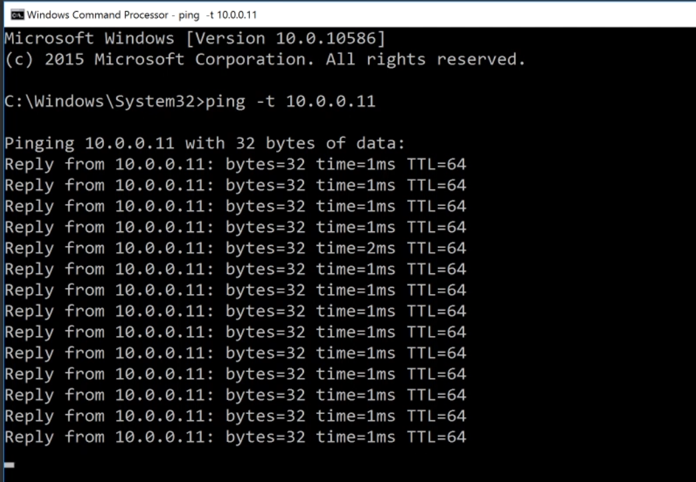

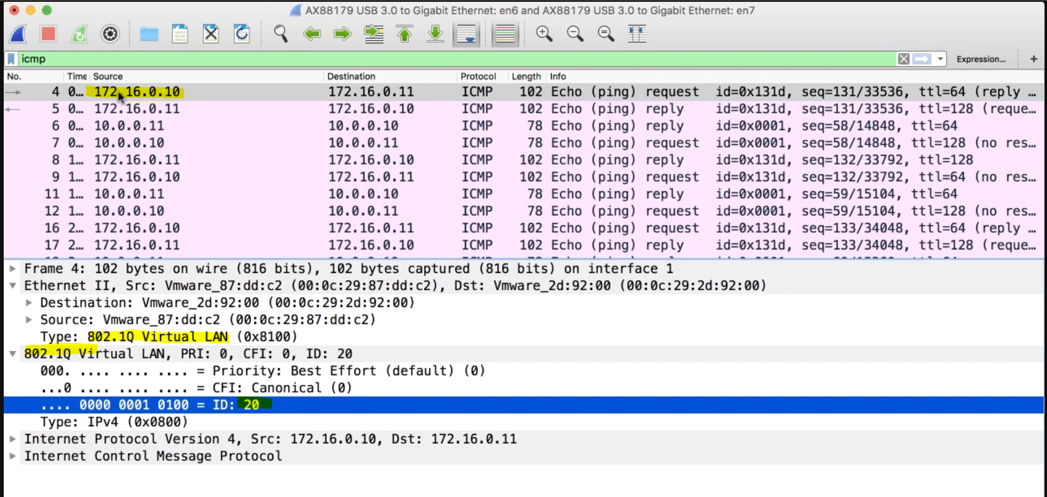

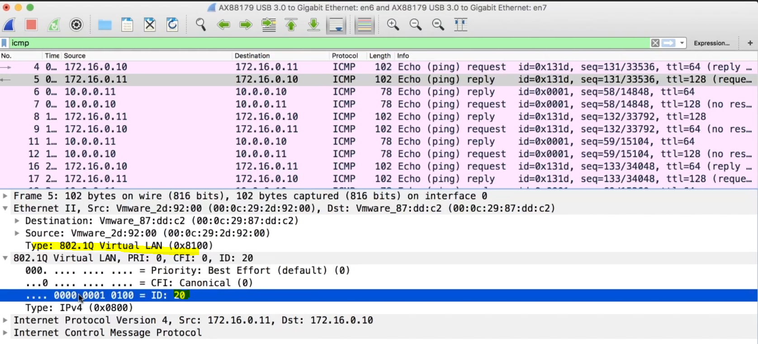

**Using ICMP** (Internet Control Message **Protocol**) to check for VLAN tag

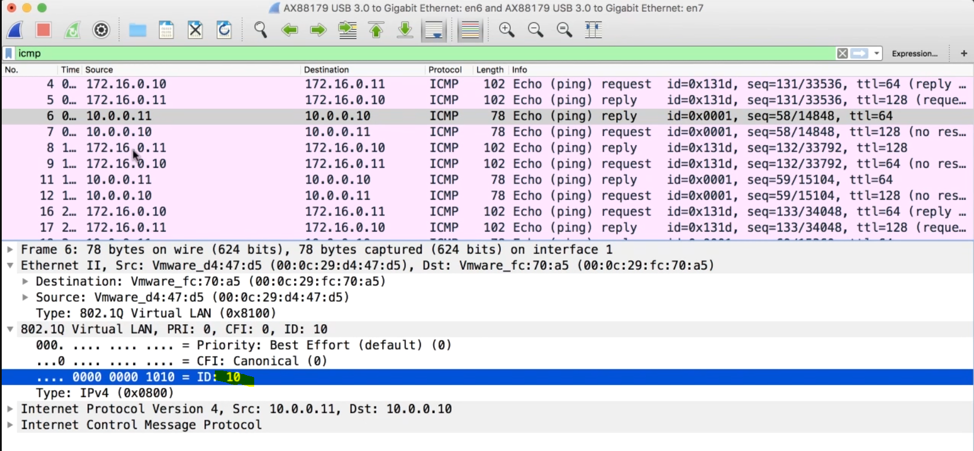

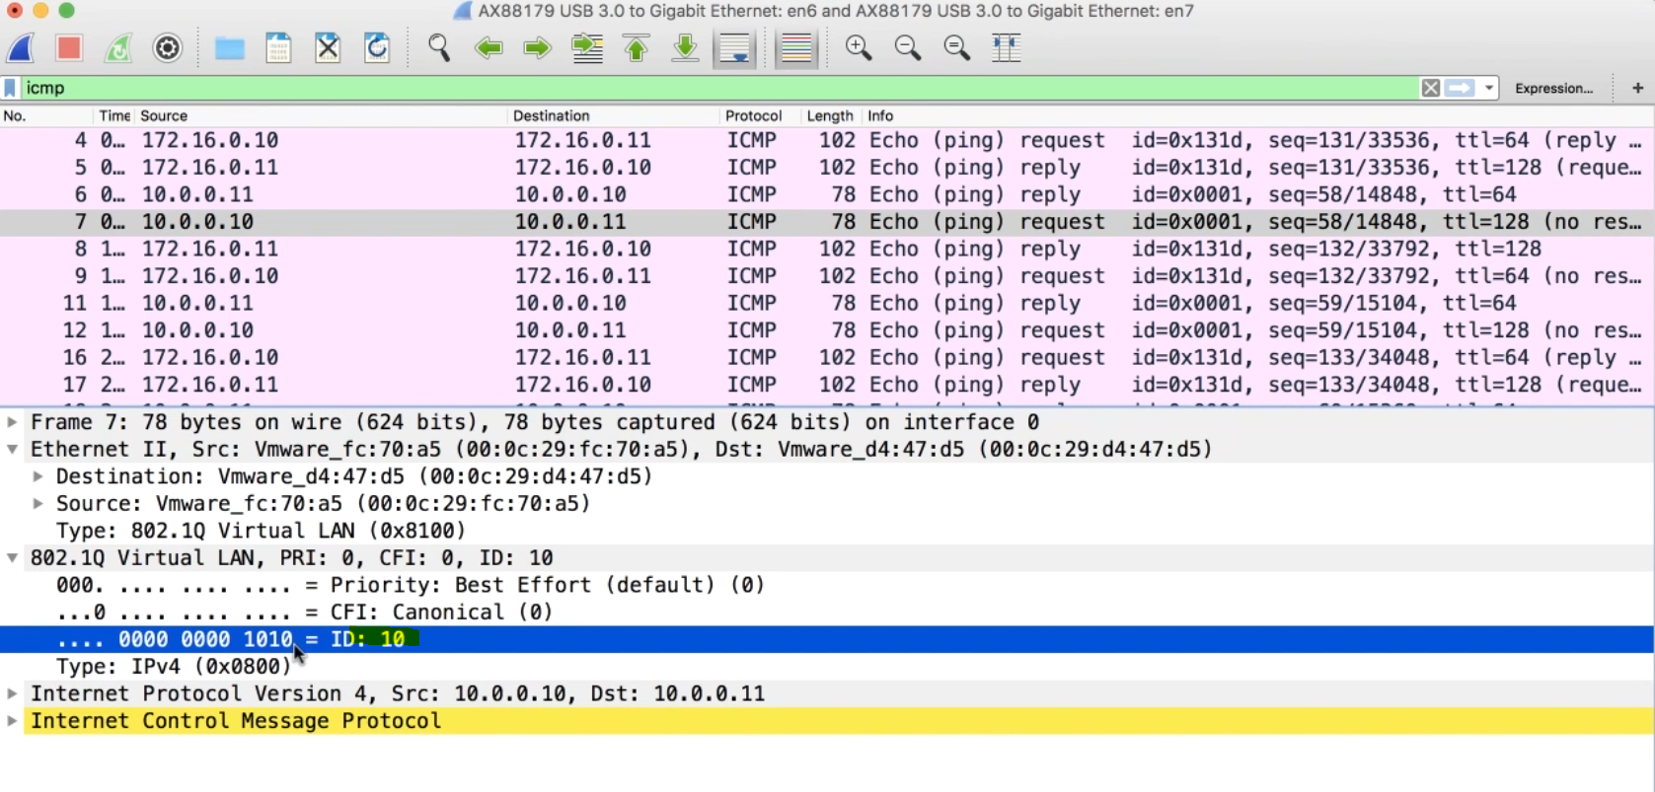

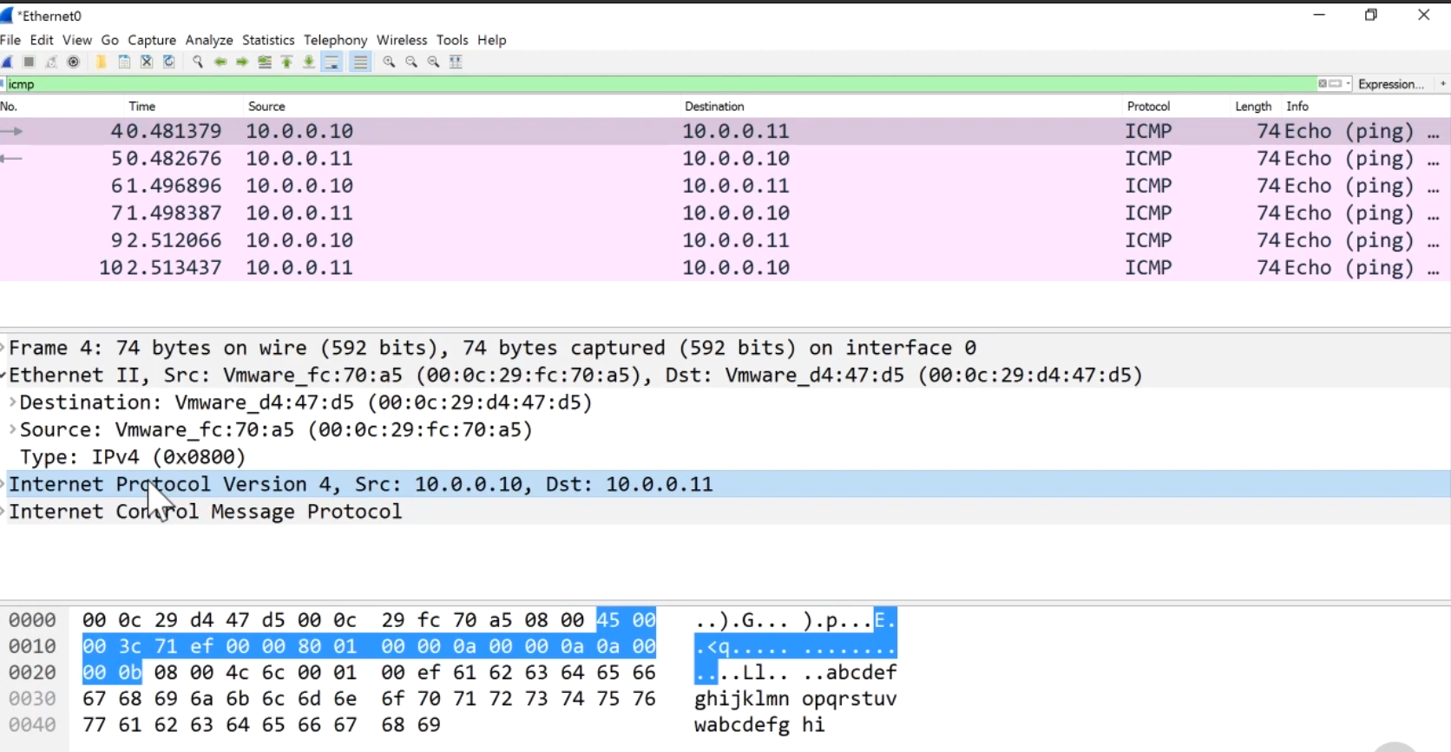

Back to windows, can’t see trunk port, because windows stripped it.

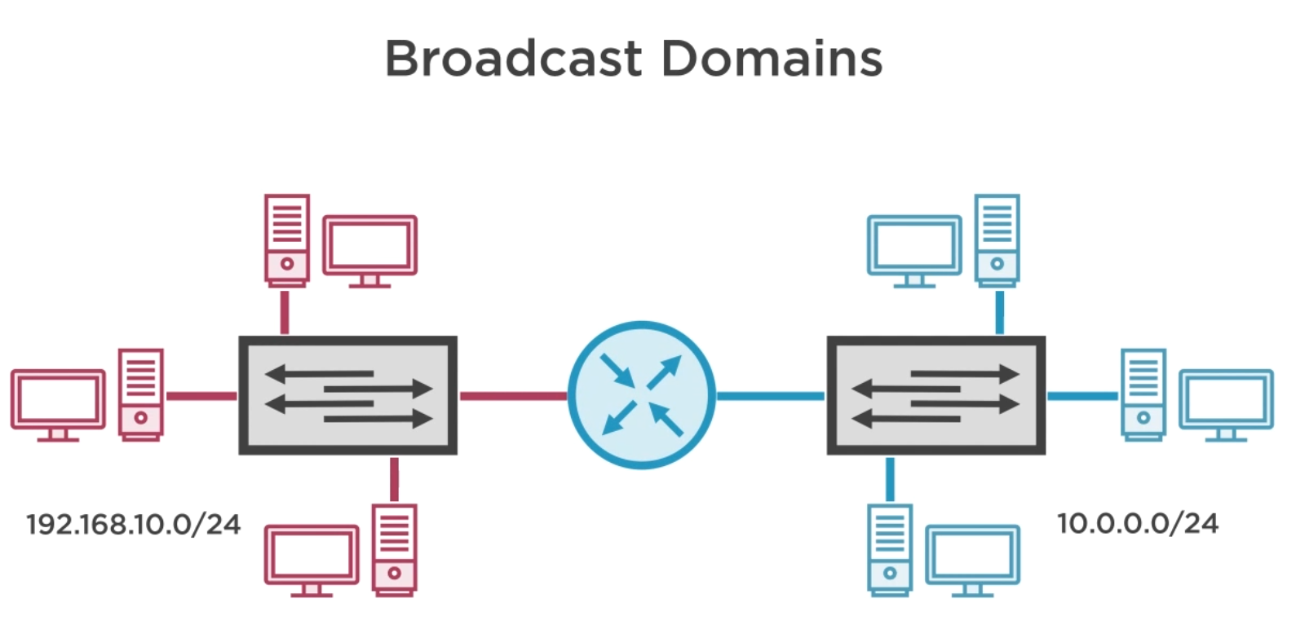

If you want them to communicate then you need a router

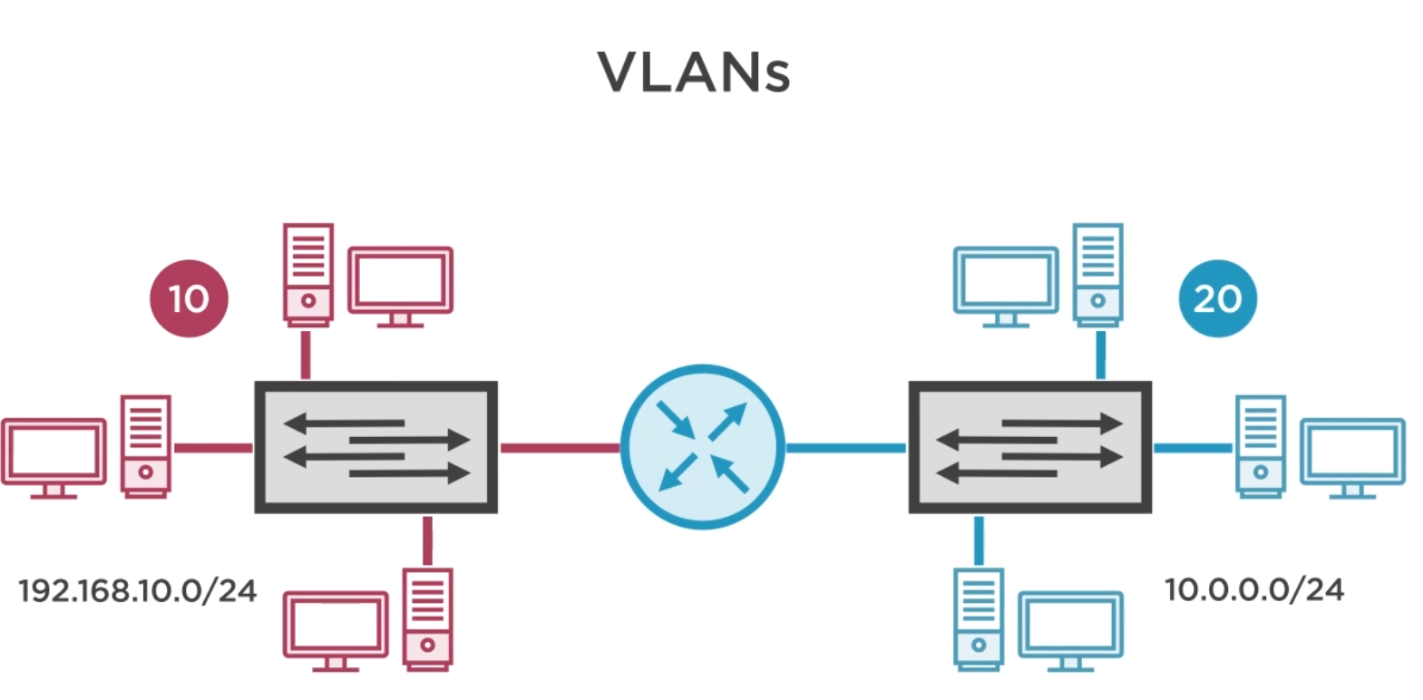

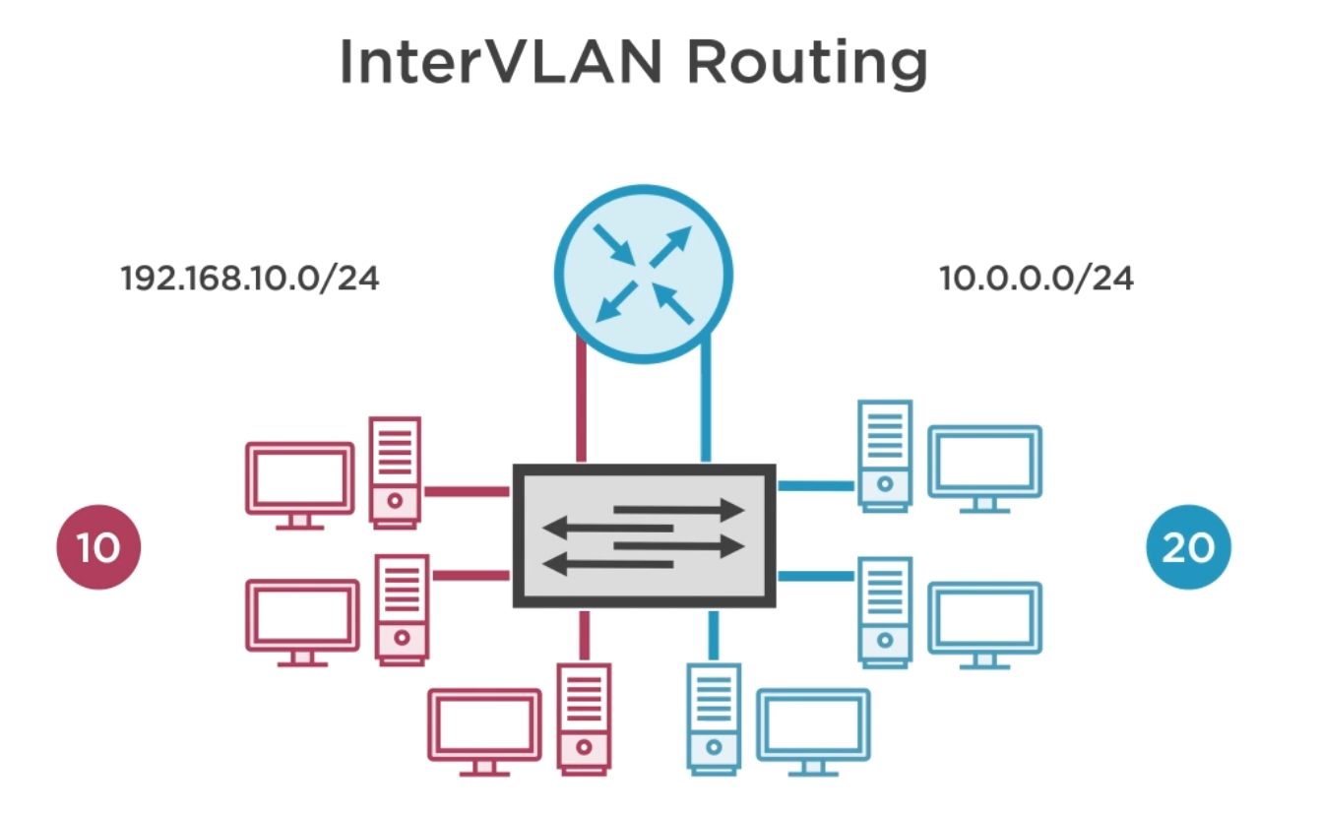

Use default gateway to communicate cross to each other or the router, and the router then can

Route it fomr the VLAN 20 network over to VLAN 10 network or vice versa.

We’re using on the router are just regular port but on the switch we configure those ports as access ports. This allow us to route between the two VLANs.

Actually to make this a little bit easier by combining our two VLANs onto one trunk link to go up on one port to the router. See below

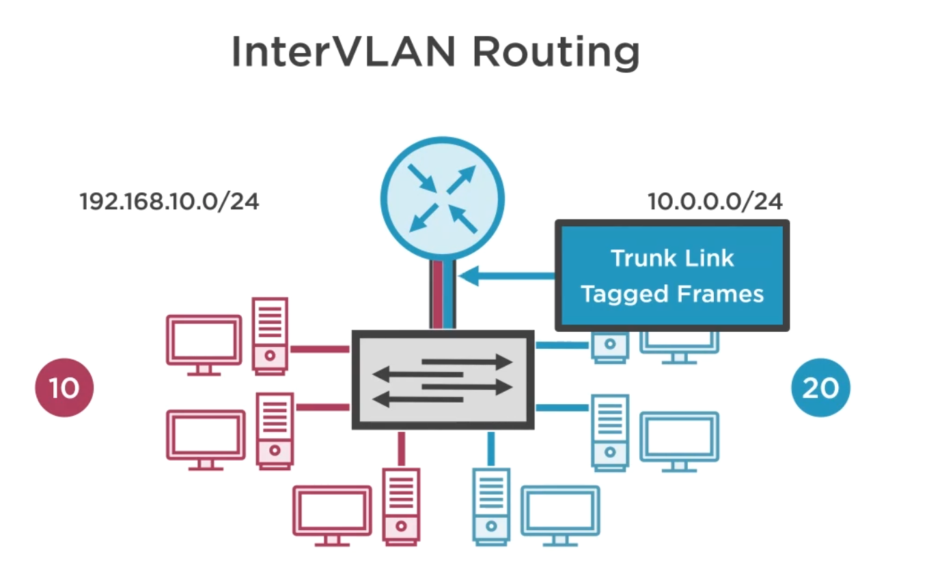

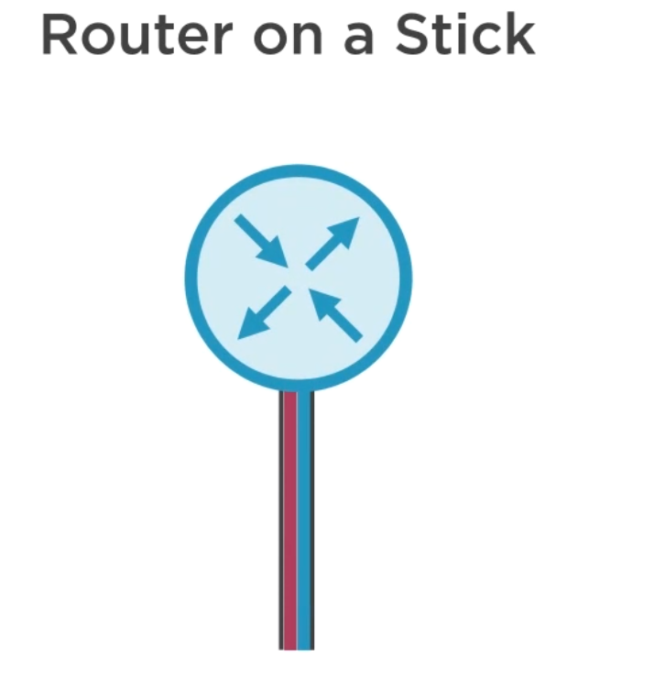

The trunking method with router is called router on the stick

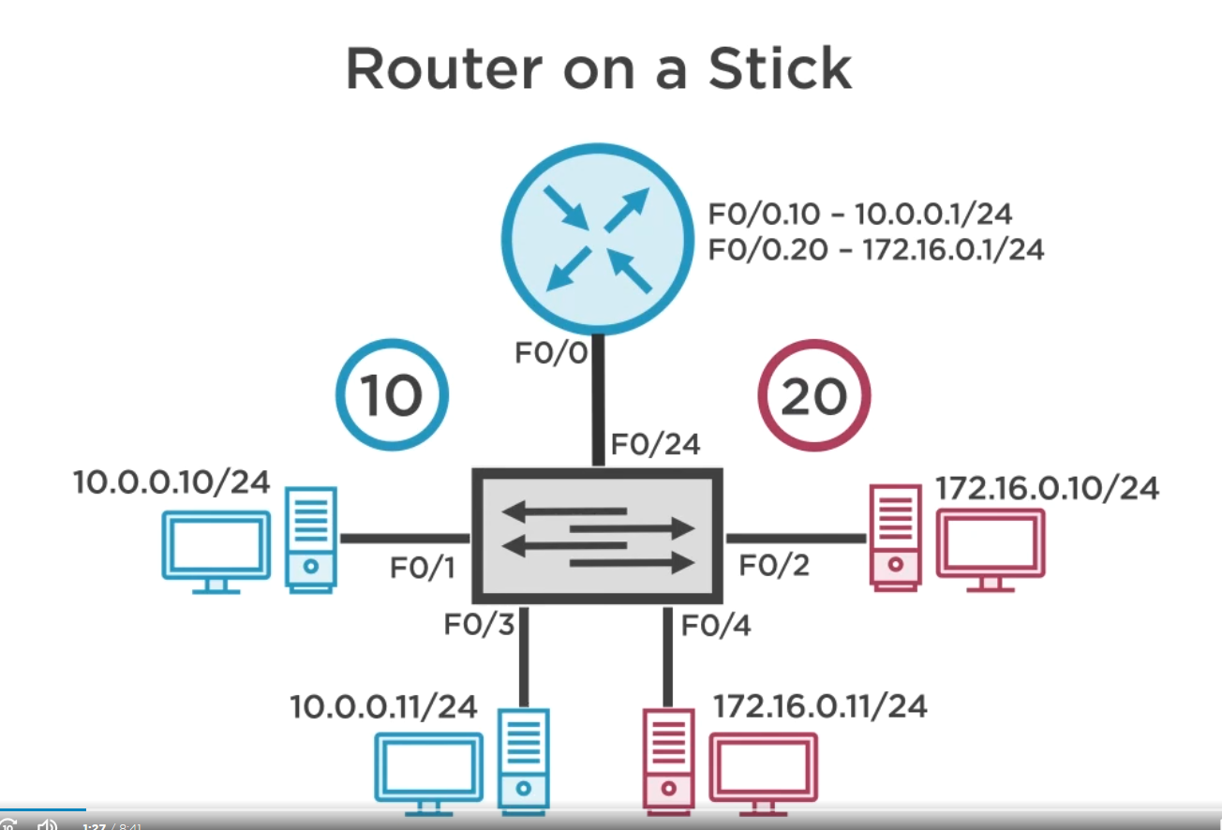

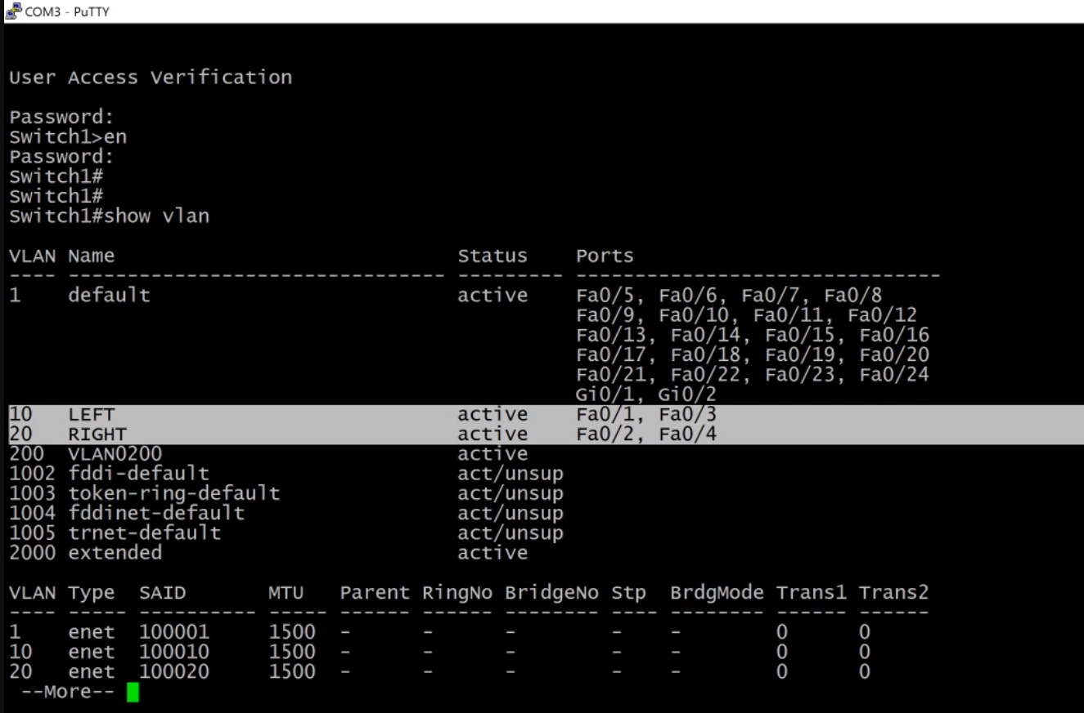

Check old switch1 settings

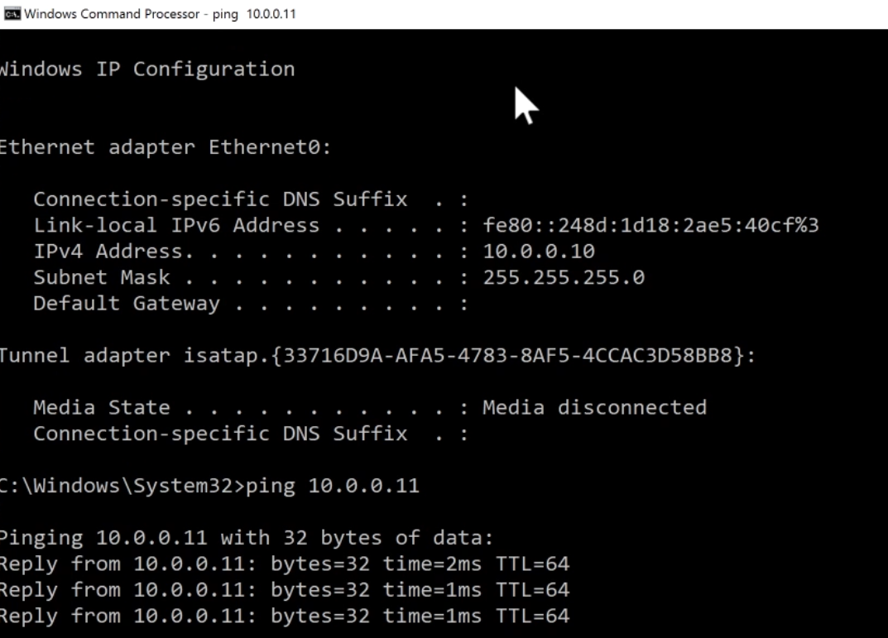

Can Ping each other with the same vlan between two switches

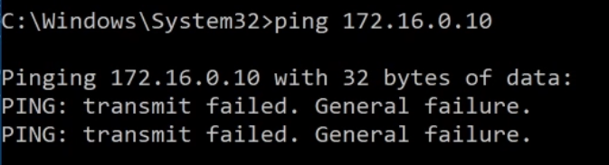

However can’t ping others subnet address on different vlan or different network between two switches

This is when interVlan coming handy

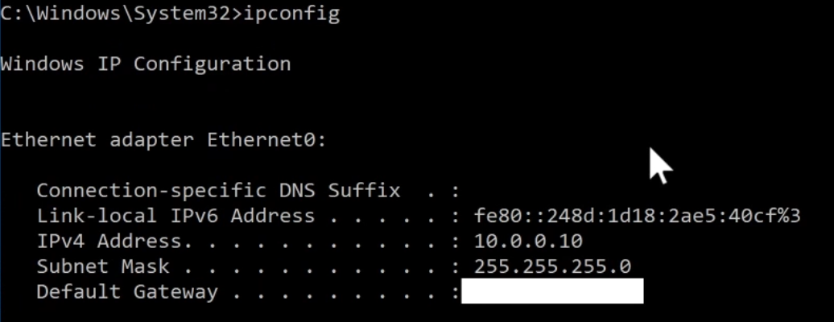

Also other problem is there is no default gateway set, so it can’t communication to different network

Lets setup :

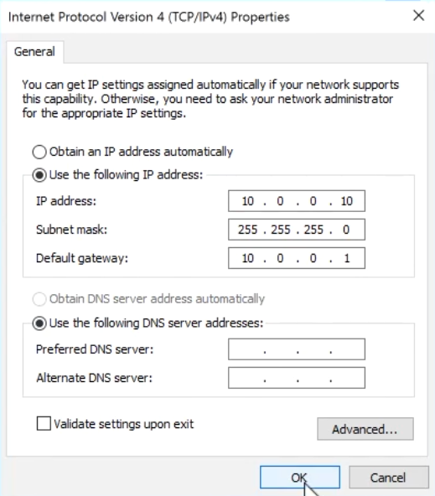

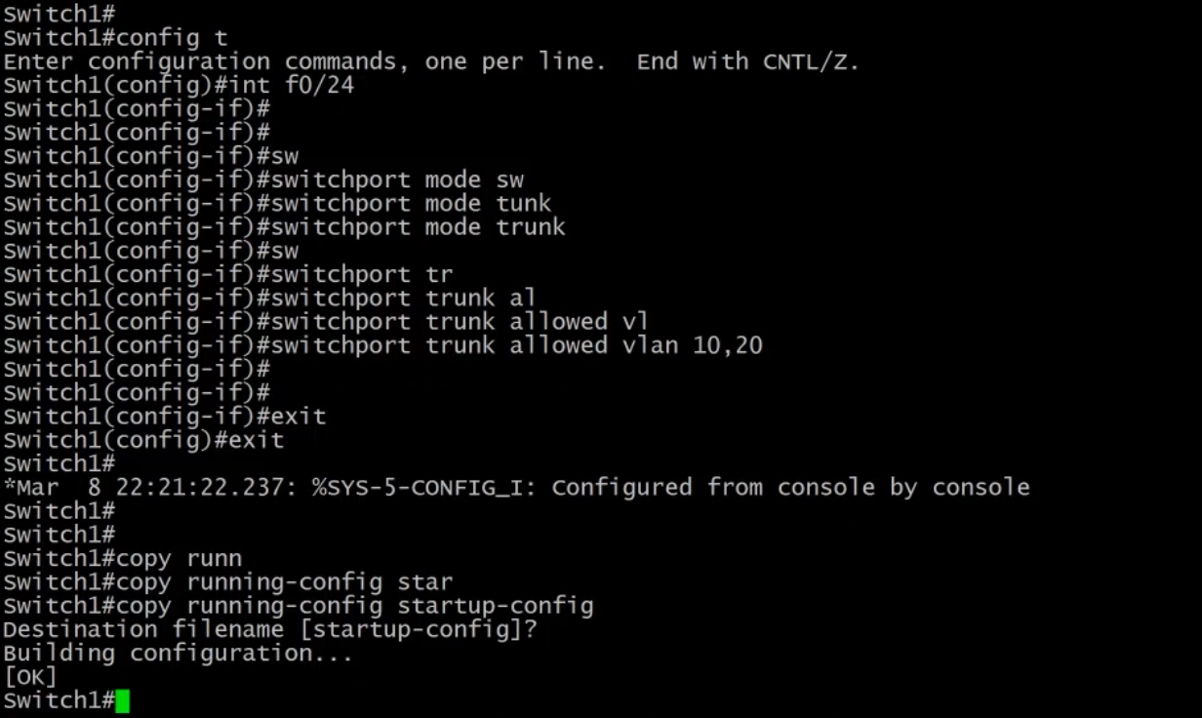

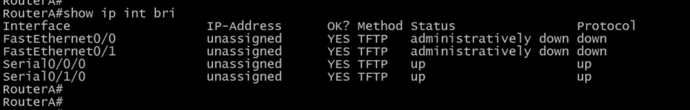

Lets switch to router A

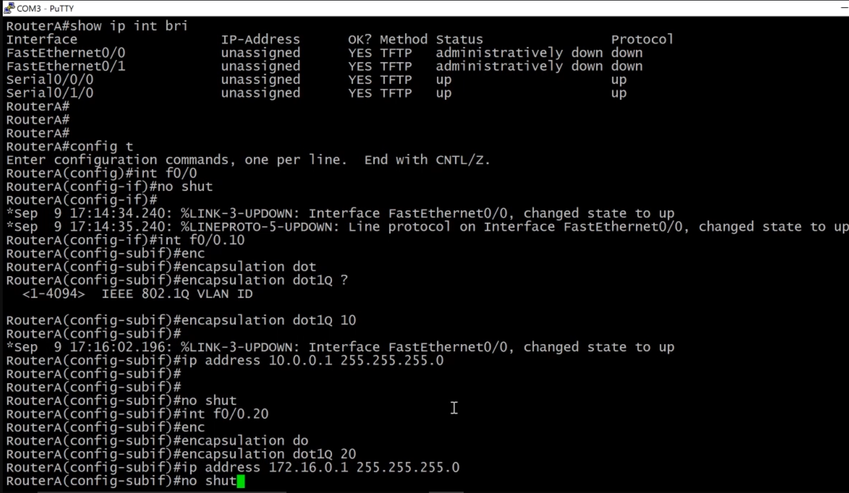

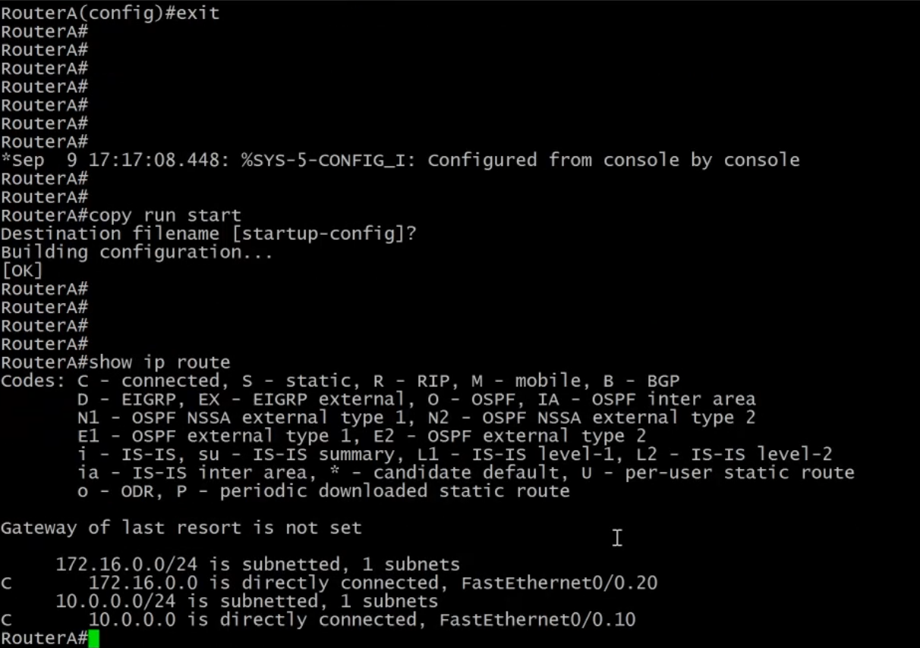

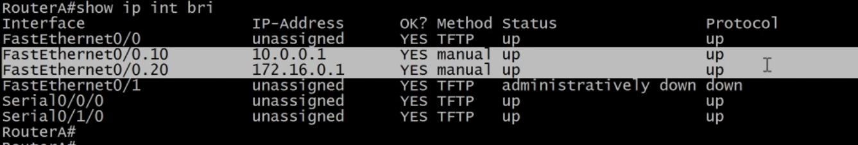

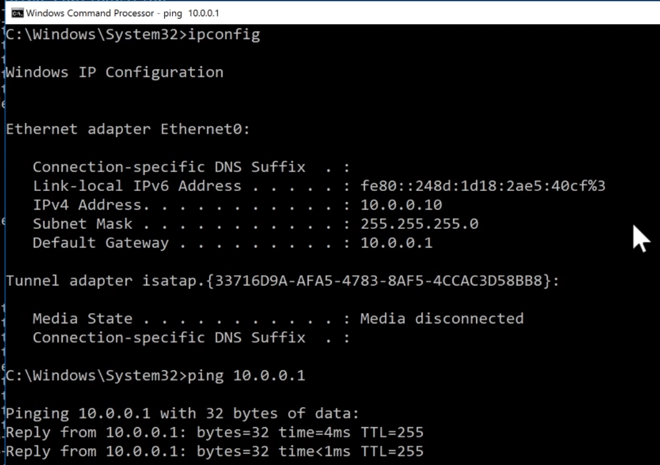

Go back to our PC and ping default gateway

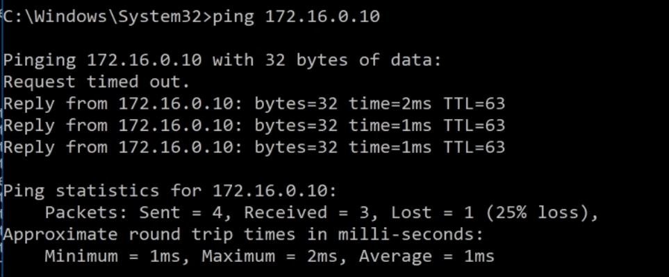

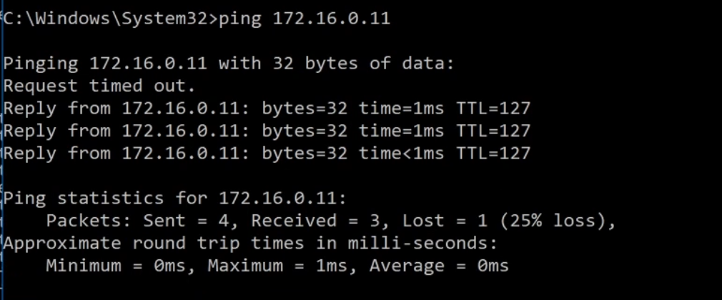

ARP ping delay that y you got request timeout message.

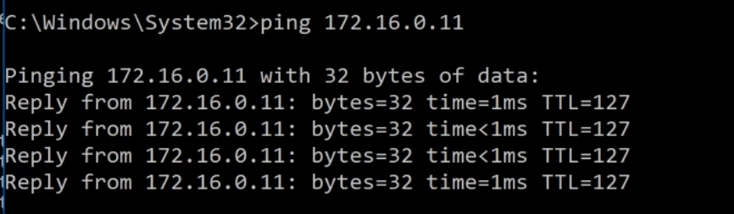

Ping again…Request timeout message is gone. The end for router on the stick

Layer3 switch explain:

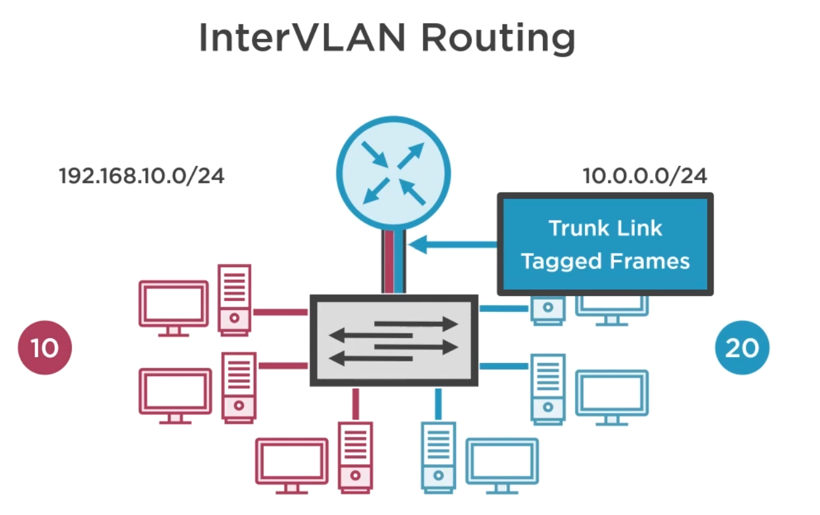

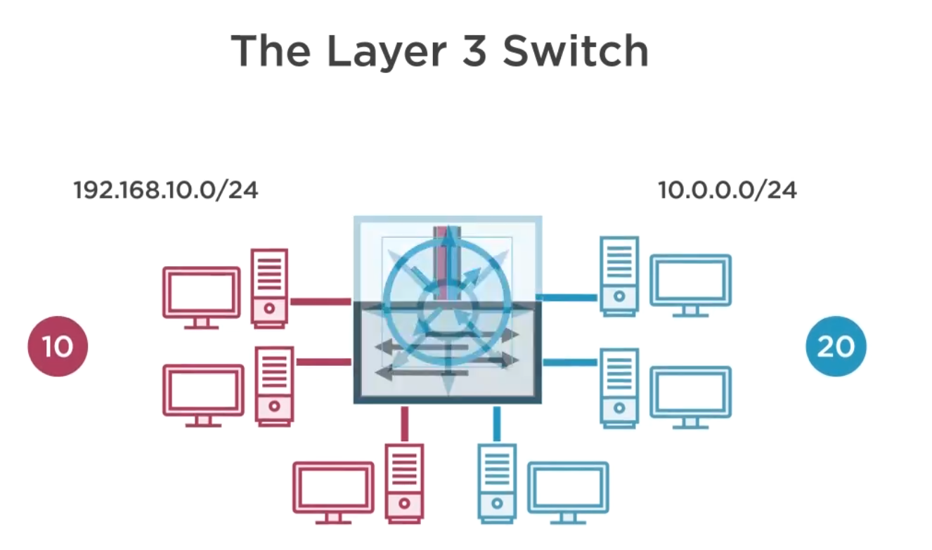

Combining router and switch together into a single device is called layer 3 switch

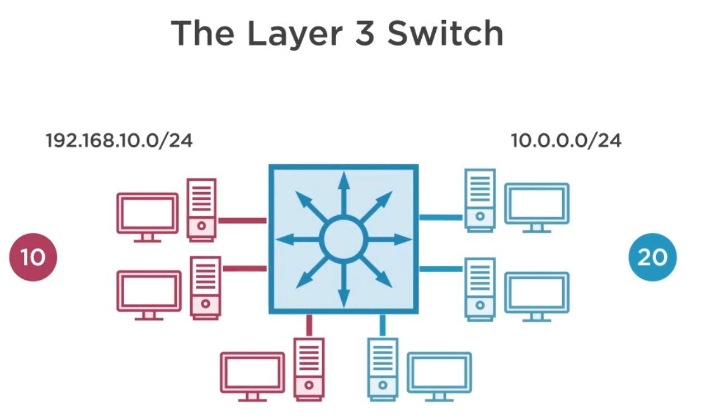

Router is for routing switches

Layer 2 is vlan and switches

Layer 3 is vlan and routing

The router at home functionally is a layer 3 switch

Mac address = layer 2

Ip and packet is layer 3

Cisco Catalyst switches:

Layer 2

* 2950
* 2960

Layer 3

* 3560
* 3750
* 3850
* 4500, 6500, 6800 among others

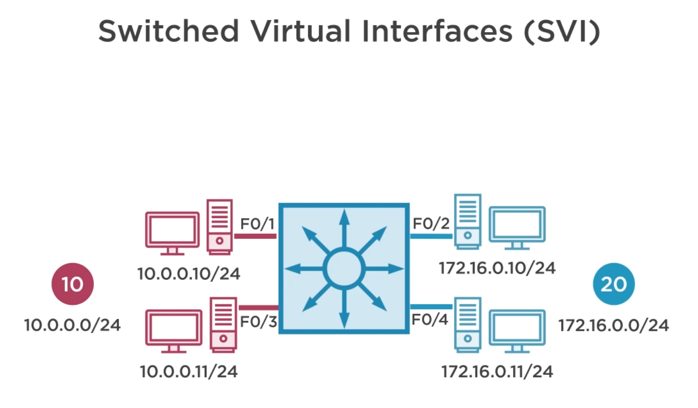

Lets set this up

SVI is a virtual interface on the switch, meaning that it’s a layer three interface, but it does not have a physical port assigned to it and we use this SVIs as the layer three interface on the VLAN, kind of like acting as a gateway for the VLAN.

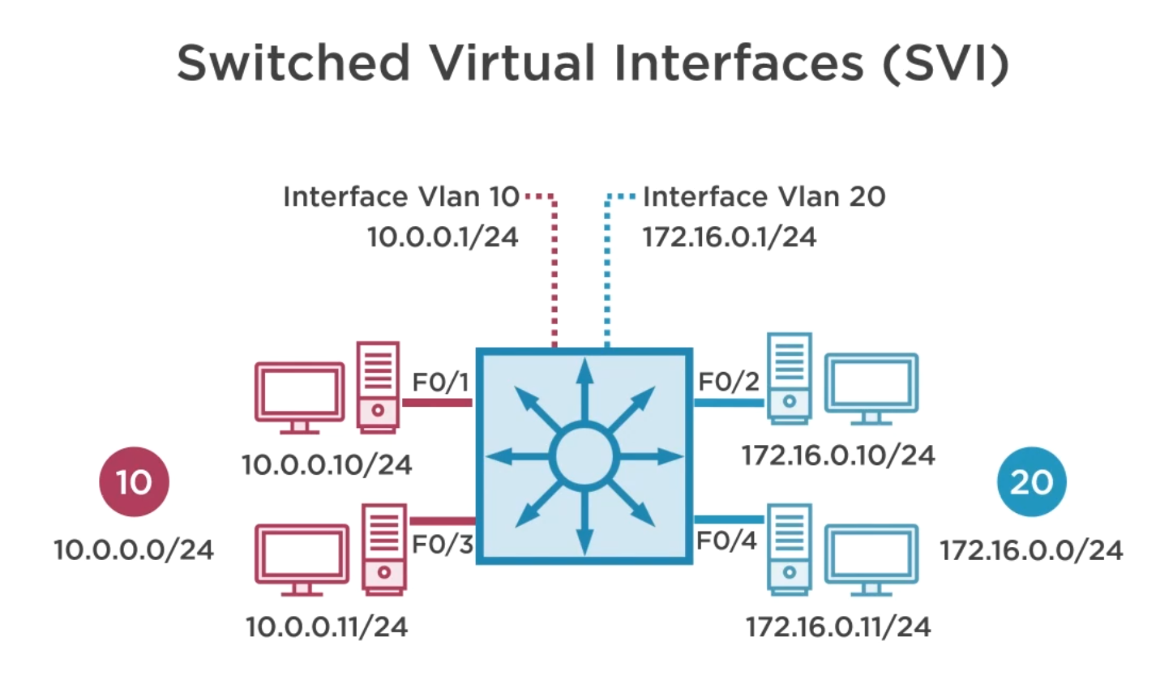

Interface vlan10 and interface vlan20 are the virtual interfaces.

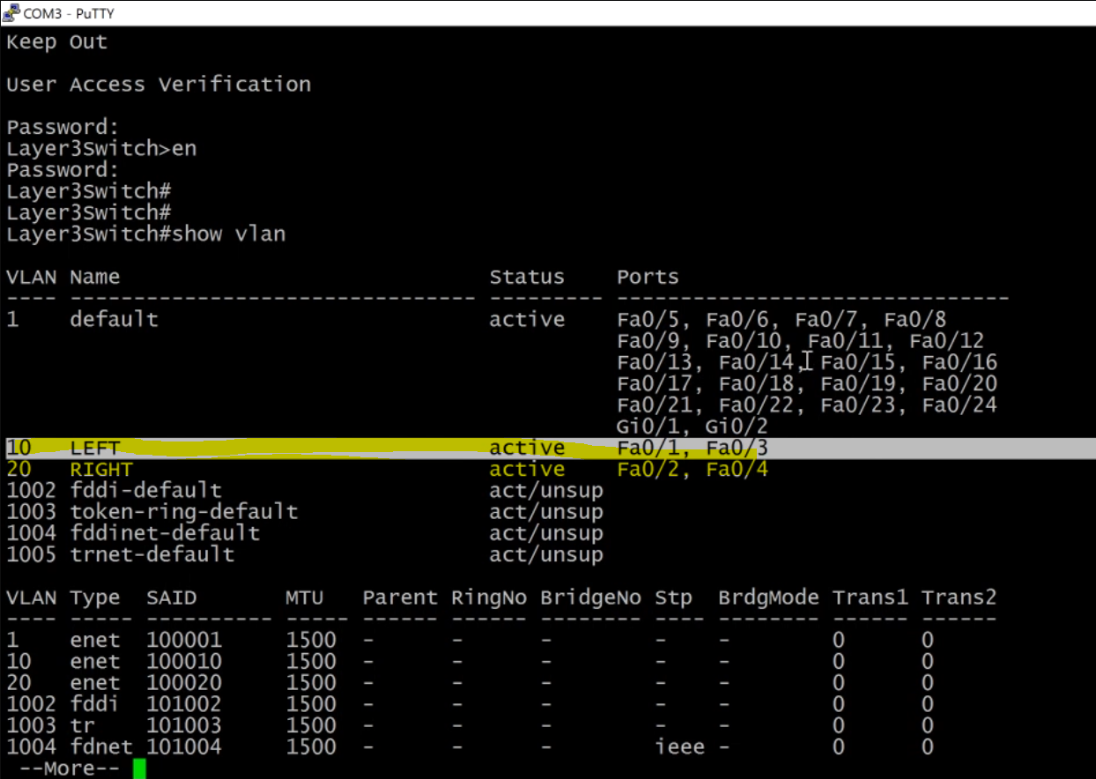

Preconfigure to boost things up.

Vlan 10 and & 20 is preconfigured (we are not using port 24 anymore)

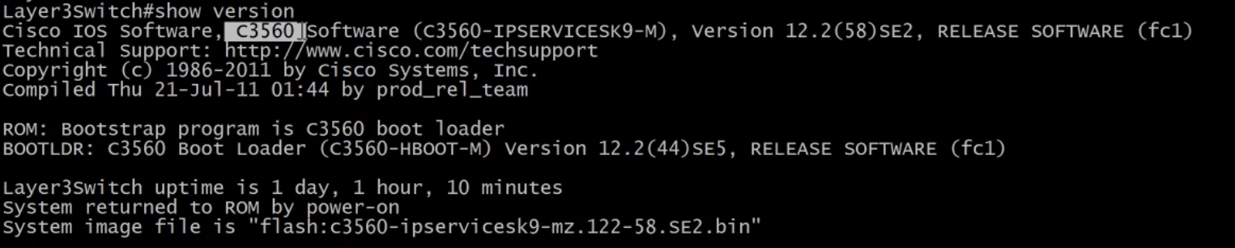

Check if it layer3 switch or not…you can is c3560 which is layer 3

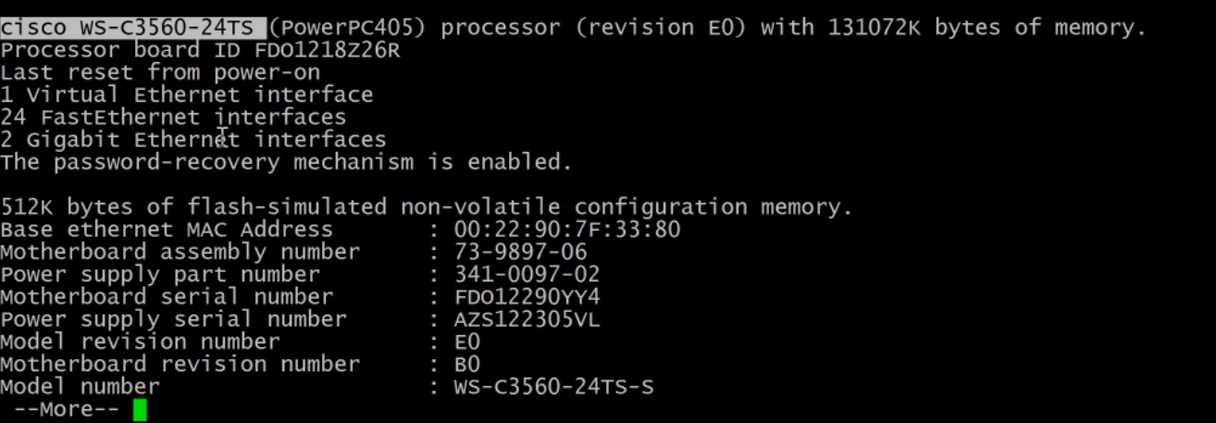

Shown the model number

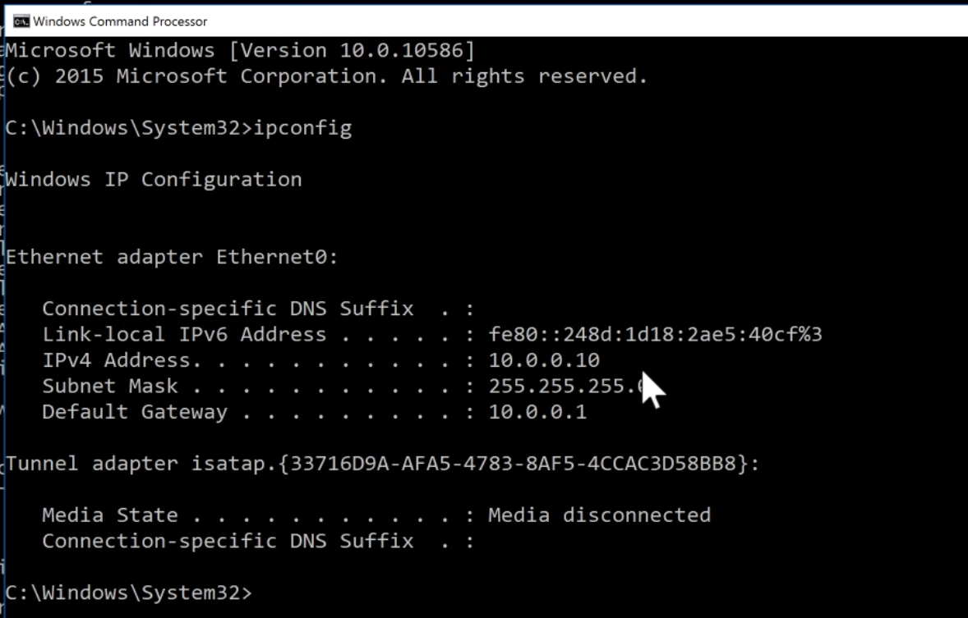

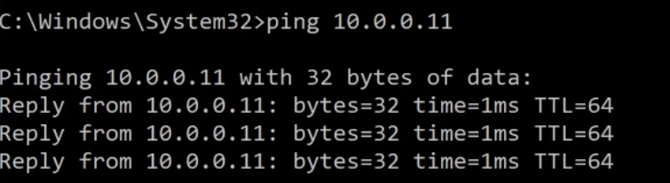

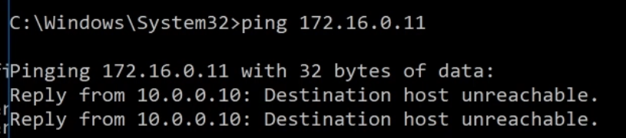

Should failed as expected, there is no default gateway 10.0.0.10 because its not configured on the layer 3 switch yet.

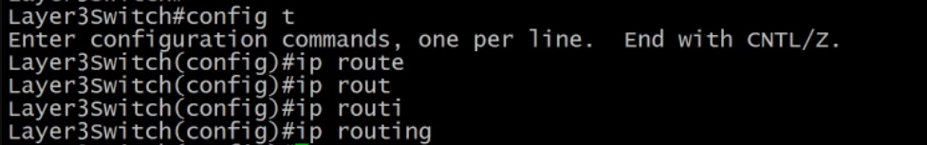

Now activate layer 3 switch.

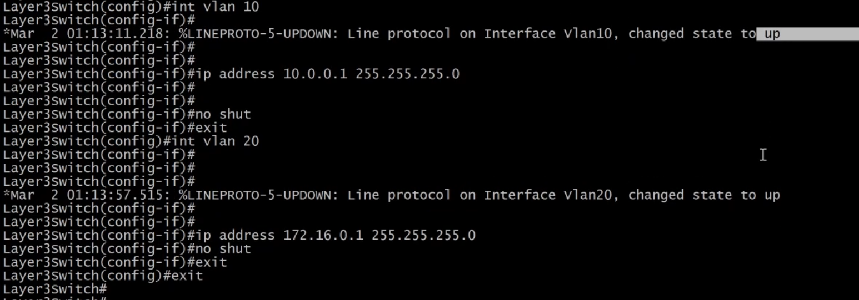

Already in the state of up, no need to issue the no shut down command, do it for good practice.

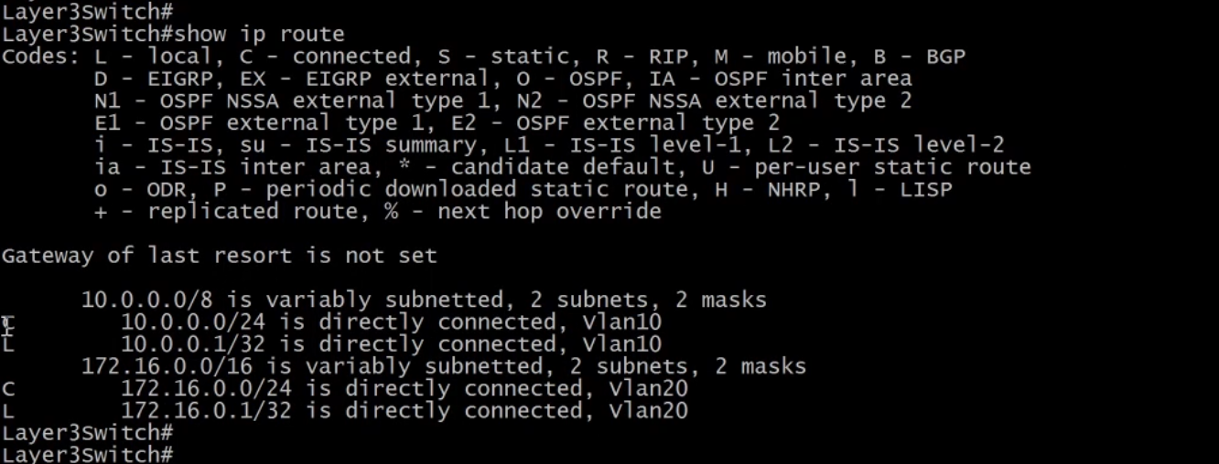

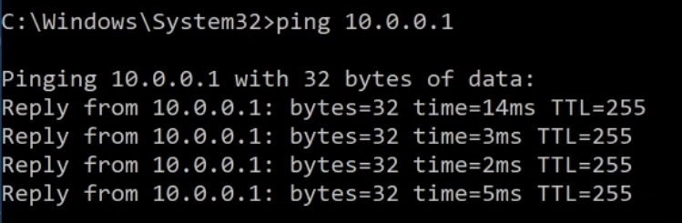

Ping default gateway now…, you are at 10.0.0.10 computer

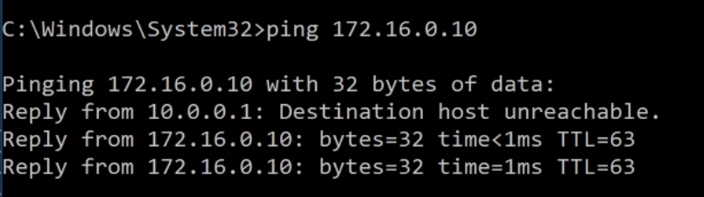

Destination host unreachable, the changes are ARP is kicking in.

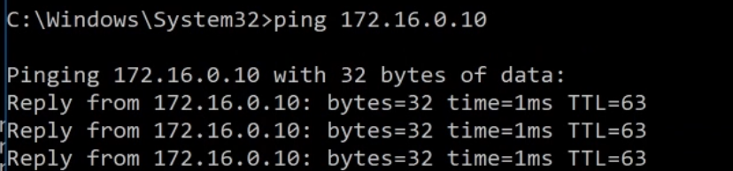

Try again, would get full reply

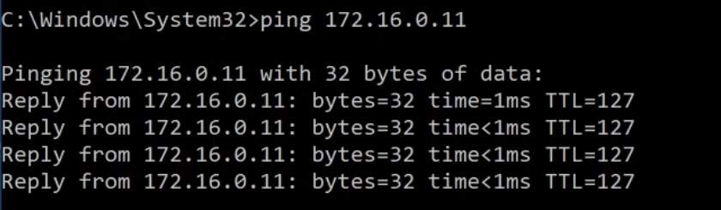

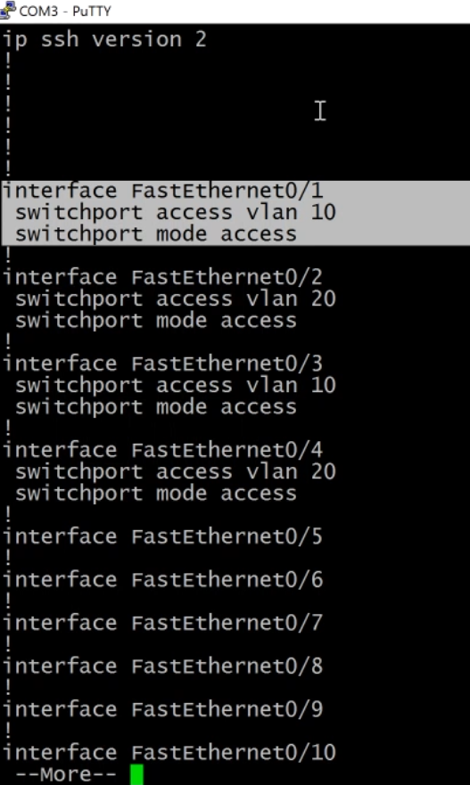

Show run

Switchport indicate is a layer 2, you can only configure vlan and other stuffs on it, and cannot configure layer 3 on it, unless you explicitly tell them is not a switchport.

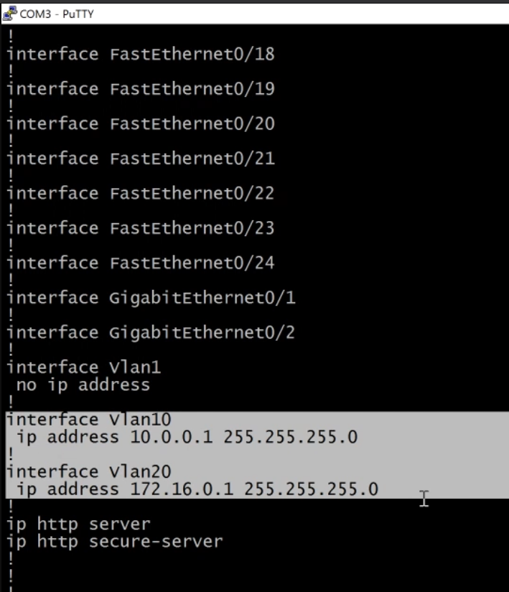

The highlited part indicate is a layer 3 switch.

This current setting for the interface perspective is configured as a layer 2 device.

We don’t get to the layer 3 configuration until we add on these switch virtual interfaces that correspond directly with the configuration on our layer two interfaces, our switch ports on the device.